Nama : Teguh Nata Kusuma

NPM : G1F021035

**SOAL**

1. Write an algorithm to convert an infix expression to postfix and infix to prefix
2. Write an algorithm to evaluate a postfix and a prefix expression

**PEMBAHASAN**

1. algorithm to convert an infix expression to postfix and infix to prefix

|  |  |  |
| --- | --- | --- |
| **Input Character** | **STACK** | **POSTFIX EXPRESSION** |
| A | Empty | A |
| * | * | A |
| B | * | A B |
| - | - | A B * |
| ( | - ( | A B * |
| C | - ( | A B * C |
| + | - ( + | A B * C |
| D | - ( + | A B * C D |
| ) | - | A B * C D + |
| + | + | A B * C D + - |
| E | + | A B * C D + - E |
| End Of Input | Empty | A B * C D + - E + |

POSTFIX EXPRESSION : - A B * C D + - E +

|  |  |  |
| --- | --- | --- |
| **INPUT CHARACTER** | **STACK** | **EXPRESSION** |
| F |  | F |
| * | ^ | F |
| ) | ^ ) | F E |
| E | ^ ) | F E |
| - | ^ ) - | F E |
| D | ^ ) - | F E D |
| ( | ^ ) - | F E D - |
| - | - | F E D - ^ |
| C | - | F E D - ^ C |
| + | + | F E D - ^ C - |
| ) | +) | F E D - ^ C - |
| B | +) | F E D - ^ C - B |
| + | +)+ | F E D - ^ C - B |
| A | +)+ | F E D - ^ C - B A |
| ( | + | F E D - ^ C - B A + |
|  |  | F E D - ^ C - B A + + |

PREFIX EXPRESSION : + + A B – C ^ - D E F

1. algorithm to evaluate a postfix and a prefix expression

*PREFIX

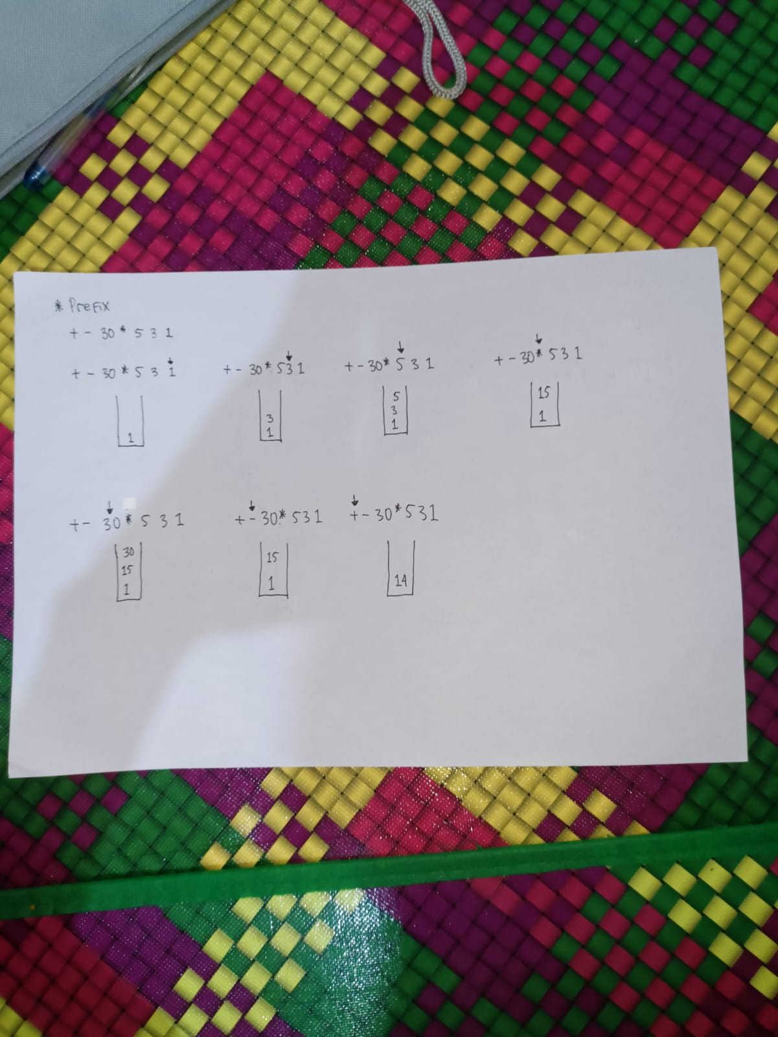

*POSTFIX

